CS-255 System Analysis and Design
Russell Buck
01/26/2026
CS 255 Evaluate a Process

Hamp Crafts Online Storefront Integration Analysis
1. Current Purchase and Supply Process
The current system at Hamp Crafts follows a linear, in-person retail workflow:
- Receive Customer Order (1.0): Initiated by the customer.
- Check Out (2.0): Processes the order and sends:
  - Order details to Fulfill Order (3.0).
  - Shipping plan to Carrier.
- Carrier → Shipper: Coordinates delivery.
- Choose Supplier (4.0): Begins contract negotiations with Supplier.
- Supplier → Fulfill Order: Sends shipment schedule.
- Fulfill Order → Choose Supplier: Returns delivery plan.
Data Sources: Customer input, carrier logistics, supplier contracts, and internal order records.

2. Additional Requirements for Online Storefront
To support online sales, Hamp Crafts must introduce:
- New Processes:
  - Online Order Entry
  - Digital Payment Processing
  - Inventory Synchronization
  - Customer Account Management
- New Data Sources:
  - Web form inputs
  - Payment tokens
  - User authentication data
  - Session logs
- Database Needs:
  - Relational database with tables for users, products, orders, inventory, and shipping
  - Secure storage for sensitive data

3. Integration Strategy
Recommended Approach: Hybrid Integration Model
- Shared Core System: Retain existing fulfillment and supplier coordination.
- Modular Additions:
  - Online storefront as a front-end module interfacing via APIs
  - Middleware to translate online orders into the existing order format
Justification:
- Minimizes disruption
- Enables scalability
- Promotes reuse of existing workflows

Submission Notes
- Format in Word with APA-style citations if external sources are referenced.
- Annotate the original data flow diagram to show proposed changes for instructional clarity.
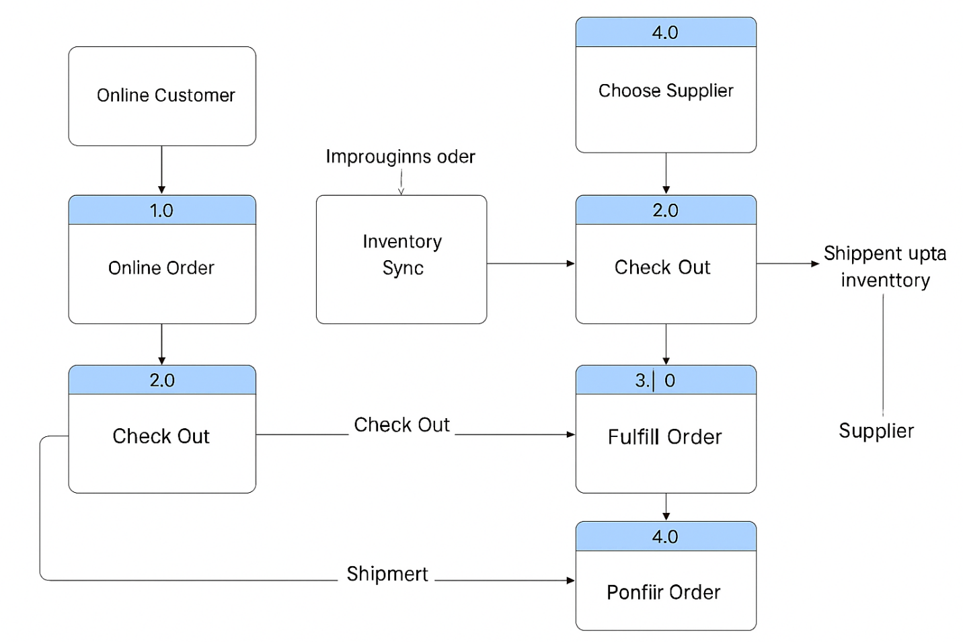

Figure-1: Updated flowchart for Hamp Crafts

